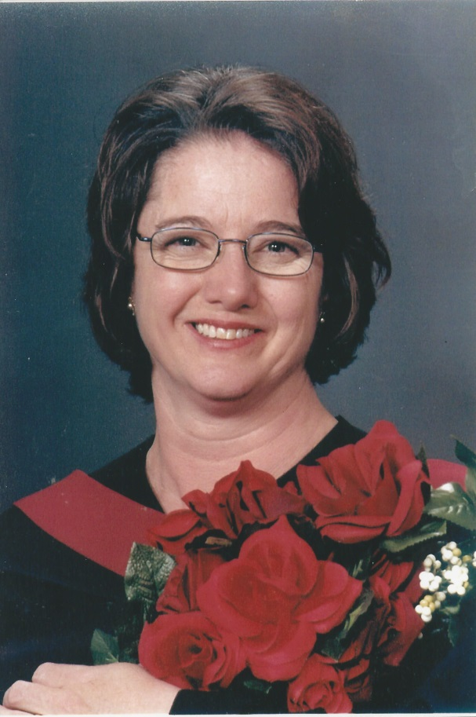
Name: Nicole Befurt

What year did you graduate from TRU?

2006

What are you doing now?

I'm a Registered Clinical Counsellor with Seasons Consulting in Kamloops, an occupational rehabilitation organization.

How did TRU help you get into grad school, find employment, etc.?

After graduating from TRU I was able to secure employment in the mental health field as a Clinical Coordinator and Psychometrist of a busy psychology office. While there I applied for Graduate school, securing a spot in the Master of Counselling program at Gonzaga University out of Spokane Washington. My degree, the Honours program, ongoing association with TRU professors, both a student and community member of the TRU Ethics Committee, as well as being a TRU mentor, assisted me in securing degree specific employment and entry into Graduate school.

What did you enjoy about TRU/What did you do while at TRU? (ie. attended conference, honours, work study, research assistant jobs, etc.)

I enjoyed the opportunity of attending university in my own community with smaller class sizes, but strong academic rigor. At the time that I completed my undergrad degree, many opportunities came available to me and my fellow classmates. I was the first student to obtain a BA Honours Psychology degree at TRU as it was introduced in my final year of undergrad. By participating in the Honours program I was able to enter the TRU Science Poster Competition. Although I was unable to attend conferences while attending TRU due to family and graduation commitments (I was Valedictorian of my graduating class), my ongoing association with the university enabled me to attend future APS conferences in San Francisco and Boston.

If current students have questions about their program/university would you be willing to be contacted? Yes

If there is anything else you wish to tell us about:

I feel honoured to be a graduate of Thompson Rivers University and continue to value the friendships that I developed with classmates and professors alike. As a whole, my educational experience at TRU was highly rewarding.

