Student Mentors for
TRU Student Sustainability Ambassador Program (2022-2023)

The TRU Sustainability Office is seeking several TRU students to act as mentors for students in the TRU Student Sustainability Ambassador Program. Please see attached document below starting on the third page, ‘TRU Student Sustainability Ambassadors Program. Terms of Reference. 2022-2023’, for a description of the program.
Terms of Reference for Student Mentors
Here are the expectations for the mentor positions:
- A minimum one school-year commitment is needed (from start of fall semester to end of winter semester). A two school-year commitment is preferable.
- Mentors, with the help of the program coordinator from the Sustainability Office, will help with training the student ambassadors
- Mentors must attend 30 to 90 minutes of weekly meetings (times are flexible)
  - both with Sustainability Office staff and student ambassadors
- Upon completion of each school year of service and a yearly ‘program summary report’, each mentor will receive a $500 honorarium and a certificate of completion.
- The position will allow the mentors an excellent opportunity to learn about many facets of sustainability, and about many of the TRU Sustainability Office’s programs and initiatives
- The mentors will help to facilitate many sustainability initiatives run by the student ambassadors all over campus
  - There will be up to 20 student sustainability ambassadors
- Mentors will have opportunities to get involved in the office’s three social media platforms (Fb, Tw, In, Tik Tok) and the office blog.

Questions and Application
For questions about the positions, please email the Program Coordinator, Anna Rogers (Sustainability Programs and Support Coordinator, TRU Sustainability Office): arogers@tru.ca
To apply for a mentor position, please email Anna with a cover letter, resume, and two references (preferably from TRU faculty or staff members).
Application deadline is September 15, 2022.

Application
Student Mentors for TRU Student Sustainability Ambassadors Program
Please email completed applications to the program coordinator, Anna Rogers: arogers@tru.ca
First and Last Name |  |  |  | Student #
Study Major |  | Study Minor (if applicable)
Address

City | Province |  | Postal Code
Cell Phone | Email

TRU Student Sustainability Ambassadors Program
Terms of Reference (2022/2023)

tru.ca/sustainability

Background
The TRU Sustainability Office’s Student Sustainability Ambassadors Program is designed to help spread the ‘spirit of sustainability’ at TRU. Students can be a force for change and improve the culture of sustainability on campus. This group will be ideas-driven, goal-driven, while being effective and trying to have fun. The program is for all students enrolled in a for-credit program on the campus. (For those TRU Open Learning students interested in getting involved in a student sustainability educators program, please consider joining the All-TRU Sustainability Educators Program).

Student Ambassadors will need to interact (either in-person or virtually) with at least 500 of their fellow students during one or more school semesters by educating them on a variety of sustainability issues or project(s). Once these 500 ‘touch points’ are complete, and a report and program evaluation form are submitted, each ambassador will receive a certificate of completion and a credit of $300 which they can put towards tuition at TRU. It is anticipated that it will take 12 to 20 hours to reach these 500 touch points.

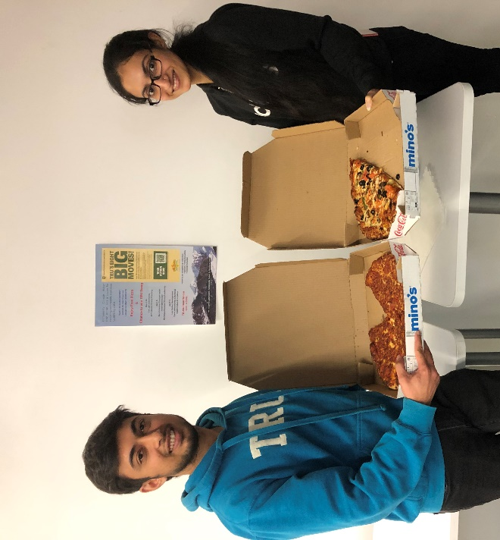
*Covid-19 Considerations – As the pandemic changes, so too will health and safety considerations for anyone involved in any programs; this applies to those participating on campus and virtually from afar.
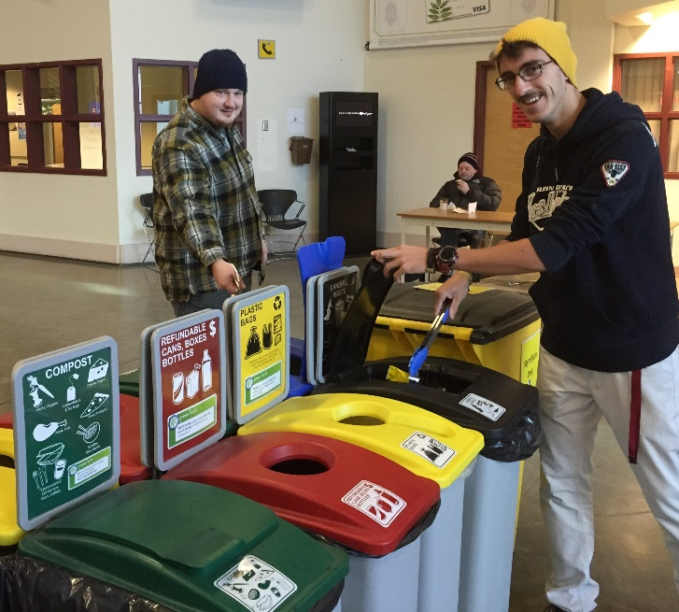

Roles and Responsibilities
- An Ambassador becomes a ‘sustainability champion’ on campus, and helps to educate their fellow students about the initiatives being promoted
  - The program is about increasing participation in, and support for, certain sustainability practices and behaviours on campus, whether new or existing, big or small.
  - Ambassadors work with like-minded students all around campus on sustainability initiatives.
- Types of campaigns
  - Ambassadors will be engaged in one or two main campaigns over each school year. (Should time permit, more campaigns can be taken on, and details will be determined).
  - One decided on by the ambassadors and in cooperation with the program coordinator,
  - The other decided on by the program coordinator to help with the efforts of the TRU Sustainability Office (examples include a cigarette butt clean-up and recycling campaign; coordinating pilot projects to start other zero-waste initiatives; efforts needed to help protect biodiversity on campus; coordination roles for a variety of office events).
- Participation
  - 500 student ‘touch points’ are needed and these can be logged during a variety of situations that suit each ambassador (for example: promoting various sustainability initiatives during ‘tabling’ sessions in a campus common area; helping at an event; running a program; presenting a short talk/Power Point in a classroom; interactions on social media posts; etc.).
  - Students’ participation requirements are anticipated to take 12 to 20 hours.
  - Minimum of one semester commitment.
- Qualifications of Ambassadors
  - Passion for sustainability; want to make a positive difference on campus.
  - Excellent communication, listening and interpersonal skills.
  - Confidence to model sustainable behaviours, and to take leadership in engaging peers in more sustainable practices on campus. Willingness to learn, help and have fun!
  - Creative thinker; ability to problem-solve; patient and flexible.

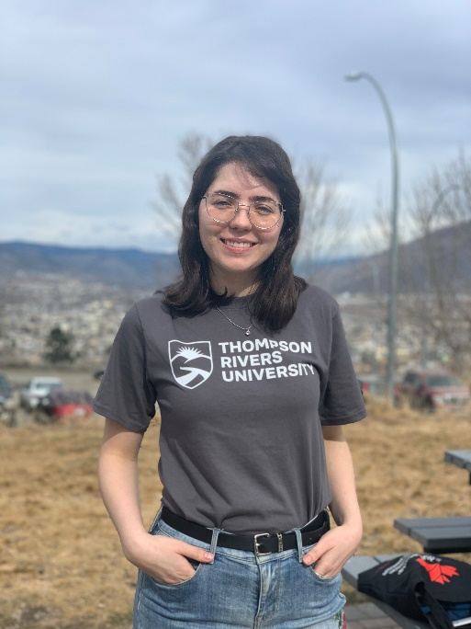
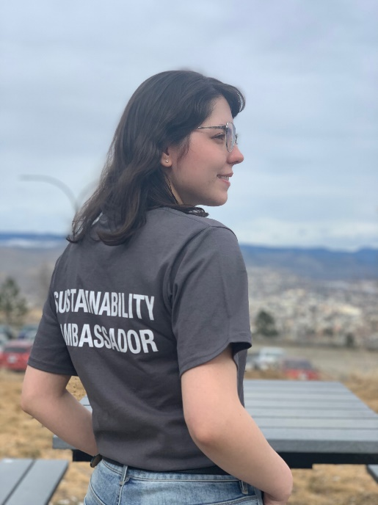

Benefits
- Deepen your understanding of key sustainability concepts, and work toward a sustainable future.
- Network with peers with similar interests while developing outreach and education skills.
- Access TRU-specific tools, tips and resources on a variety of sustainability topics.
- Ability to apply for funding through the TRU Sustainability Grant Fund for sustainability initiatives that involve TRU staff, faculty or students.
- Opportunities to engage with communication tools (social media, Printshop, etc.).
- Feel good about making a difference; help save resources and money.
- Access to funding for projects, and a free t-shirt!

Meetings & Schedule
- Program runs all year
  - Orientation and training in conducting sustainability outreach will be provided to all ambassadors at the start of each semester in September, January and May. Training session dates/times will be determined based on availability of ambassadors.
  - Ambassadors will have the support of the program coordinator(s) for any issues.
  - The program offers resources and educational opportunities to give ambassadors the skills/knowledge needed to promote sustainability.
  - Regular ‘coffee meetings’ for ambassadors (15/30 mins) to make sure all issues are addressed by the program coordinator.
- Celebrate Victories
  - The program will recognize ambassadors’ contributions at an annual event in April as a thank-you for their valuable contributions.

Application Process
Students interested in joining this program must submit their application to the contact below by September 20 (for Fall semester participation), January 20 (for Winter semester participation), and May 20 (for summer semester participation). Once these three things below are submitted, a short interview will be set-up with the program coordinator.
- Contact Information (on next page).
- A 100 to 200 word description of why you want to join the program, and why sustainability is important to you.
- Two references preferably from TRU staff or faculty members, but employers will also work. Please include contact information as well.

Contact / Questions / Submit Applications
Questions about the program can be directed to the program coordinator:
Anna Rogers, Sustainability Programs and Support Coordinator:
arogers@tru.ca / 250-852-7153
Sustainability Office, Thompson Rivers University

Contact Information – TRU Student Sustainability Ambassadors Program
Please email completed applications to the program coordinator, Anna Rogers: arogers@tru.ca
First and Last Name |  |  |  | Student #
Study Major |  | Study Minor (if applicable)
Address

City | Province |  | Postal Code
Cell Phone | Email

