Memory Handout
Understanding memory
It is important to understand how your brain stores information before you try to improve your memory. Unlike a computer, your brain cannot store information instantaneously. It requires time and effort for someone to memorize something. However, by using proper studying techniques the amount of time and effort required can be reduced.
Most memory techniques fall into the general areas of association, repetition, rehearsal, and mnemonic devices.
Curve of Forgetting
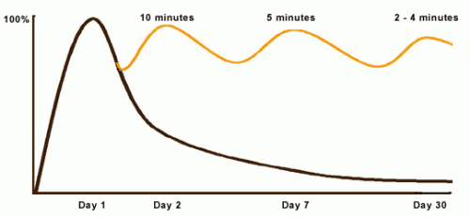
When you first something, it is within a very short period of time that you start forgetting what you have just learned. The brain does this naturally to keep itself free of useless information. As you can see from this graph it is important to review concepts that you have just learned. (Graph shows that reviewing for 10 min on day 2 will help you regain 100% memory of the concept, further reviewing for 5 min on day 7 bring it back to 100%....etc.)
There are 3 different types of memory.
Sensory memory is gathered from the 5 senses and is often hardwired into your brain rather quickly.
Short-term memory is limited to 5-9 separate facts and fades very quickly from your brain.
Long-term memory is facts and concepts that have carried over from short term memory to become a permanent part of your brain.
The main goal when memorizing is to convert your short term memory into long term memory. This is done mainly by repetition.
There are 3 main strategies to building effective memory.
Get organized:
-First get motivated. Set out a time you are going to study and then actually do it.
-Reduce interference by studying a quiet environment away from distractions.
-Be selective, carefully choose the topics that you are going to study ahead of time, rather than trying to study everything at once.
-Intend to remember, stay focused on the task at hand while studying. Do not allow yourself to daydream and get distracted.
-Start from general topics and work down to specific. This will help your brain form the proper associations that will help you understand and memorize what you are studying. 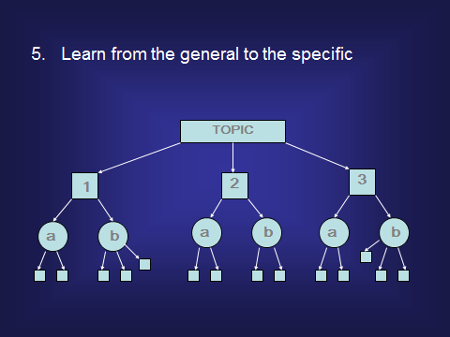
-Look for relationships among ideas: How does it relate to the key idea? How does it relate to the course as a whole? Does it relate to my personal goals?
-Create associations: What do I already know about …….?
Get active while studying:
-Move around in your environment when you feel yourself beginning to burn out, leave your notes and take a short walk.
-Create graphics that will help you visualize what you are learning. Ex= Venn Diagrams, charts, tables.
-Create flashcard to test yourself and help you learn.
-Read your lecture notes, write your own version of the lecture notes, recite your own notes, and then review your notes.
-Benefits of Exercise: Studies have shown that exercise has a positive effect on short term memory, since we are all athletes this means that we should already have an advantage when it comes to memory skills.
-Studying in groups. Some people find it beneficial to study in groups. When doing so it is important that you are focused on actually studying rather than alternatives. Some constructive strategies that can be used in groups are to ask questions, asking questions helps both yourself and your group partners by a) reinforcing the material for the person answering the question and b) teaching the person that asked the question. Comparing notes and test answers can be beneficial, as long as you don’t do this during tests. Drilling each other on the material can also be helpful, read through your notes and ask questions throughout.
Mnemonic devices:
Mnemonic devices are extremely useful when memorizing material. One mnemonic device strategy is to create acronyms. Take the first letter from each word you are trying to memorize and combine them to make a new word that is easy to remember. An example of this would be BEDMAS, which represents the order of operations in mathematics: Brackets, Exponents, Division, Multiplication, Addition, and Subtraction.
Another strategy is use sentences to remember the first letter of each word you are trying to memorize. An example of this is My Dear Aunt Sally, which is used to memorize that you multiply and divide before you add and subtract in mathematics.

