Office of Safety and Emergency Management Report

2023 Winter Semester
____________________________________________________________

Introduction
This report provides an overview of the activities of the Office of Safety and Emergency Management (OSEM) as well as incidents and injury trends for students, staff, and visitors for the period of January through April 2023.
OSEM supports the university’s mission by implementing industry leading best practices in the areas of Occupational Health and Safety as well as Community Safety and Emergency Management.

Executive Summary
During the 2023 winter semester, the Office of Safety and Emergency Management assisted students, staff, and faculty in support of the university’s mission. Highlights include:
- Safety incident management system, Prismatic Data Solutions, has been implemented and staff are in the process of preparing for a soft launch this fall.
- Updated Lockout Tagout procedure to include reference to “Zero-Energy.”
  - Available under Safe Work Procedures on the Risk Management webpage.
  - Training course is being developed and will be available in the fall.
- Updated the Contractor Safety Questionnaire to capture information on certificates, training, insurance, and standing with WSBC, which will allow OSEM and Facilities to be more proactive in implementing control measures.
- Created a Biosafety Orientation Training, which has been reviewed by the Biosafety Committee and made available to students and researchers.
- Created weekly Safety Toolbox talks for committee members to discuss with their departments.
- Respiratory Protection program rolled out with training course and fit testing scheduling for summer and fall.
- Camera systems training has been completed by security staff in order to better utilize existing systems.
- Negotiations for a new three-year security contract have been signed, with Paladin Security being awarded the contract.
- Saw a reduction in vehicle break-ins over the winter term because of adding additional overnight patrols for troubled areas on campus.
- The Community Safety Council strengthened our existing partnership with the City of Kamloops Community Safety Officers (CSO’s). A CSO representative attended the April meeting and highlighted some ways in which they can work with our existing security team to enhance safety measures on campus.

Incident and Injury Statistics:

Figure 1: Winter Semester Incident Count (5 year progression)
Winter 2023 incident reports are consistent with previous years where staff and students were present on campus.
Figure 2: Injuries (reportable, first aid, recordable) per Community Member Category - Winter 2023
As shown in Figure 2, our highest risk group for injuries is students. Of the 38 injuries, the highest rate of student injuries came from the School of Trades (12) and Other/Unknown program (15).
WorkSafe BC - Lost Time Accidents (LTA)
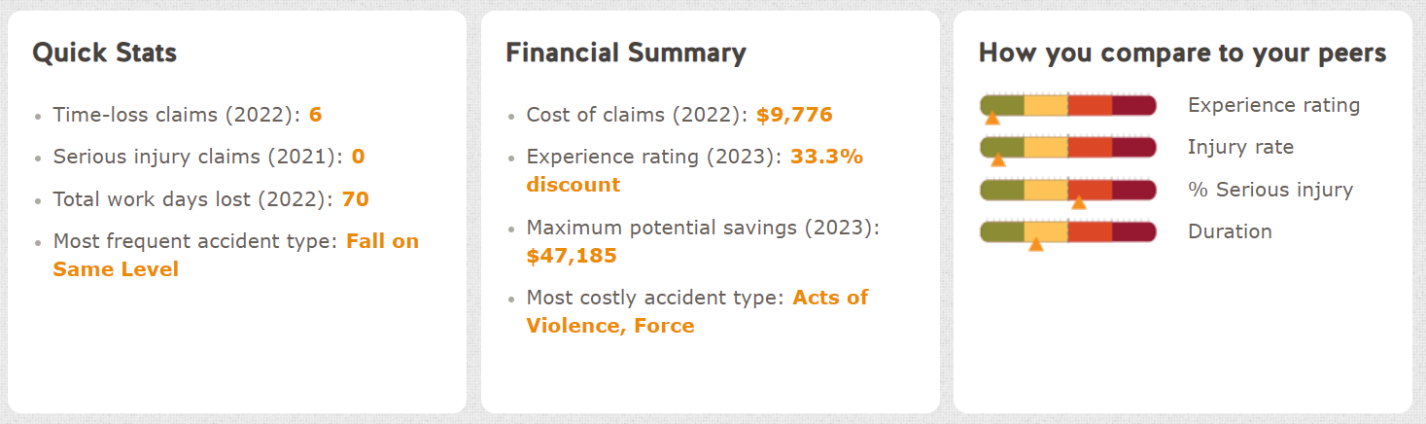Figure 3. Lost Days
Falls on Same Level (Slips/Trips and Falls) continue to be TRU’s most frequent incident type (21% of all incidents). Continued efforts are being made with Facilities to identify damaged and unstable walk paths and enhance our sanding and clearing of walk paths and parking lots. Due to Kamloops’ freeze/thaw winters, this continues to be an issue and the university’s mitigation strategy is ongoing. As noted above, OSEM will be incorporating educational awareness throughout the year with seasonally specific hazard awareness and reporting campaigns (i.e., Safety Toolbox talks, TRUSafe app).

Prismatic Data Solutions
Prismatic Data Solutions is OSEM’s new safety incident management system. It is a complete and robust system for managing all aspects of the incident reporting and investigation process. It features six modules, Incident Management, Hazard Reporting, Inspections Management, Worker/Training Management, Return to Work, and Safety Committee Meetings, most of which are live and usable.
To date, OSEM has input historical staff incident data and all authorized users are in the system and able to access it. In the coming months staff will work on building up the system and creating proper hierarchical connections for notifications. OSEM anticipates presenting the software to leadership in the fall, followed by a soft launch to the rest of the university community.

Community Safety and Emergency Management (CSEM)
Security Summary:
Figure 1: Security Event Responses
General Entry requests and calls to open and lock Unsecured Doors continued to mark the highest overall security events for the Winter 2023 term. These numbers are consistent with the Fall Term and will likely decrease over the spring and summer terms as fewer people are on campus. The number of disturbance and trespass events continues an upward trend seeing the highest number recorded over a four-month period, up 62 from the Fall.
In response to the increased number of vehicle break-ins during the fall term, an additional overnight guard was added to the patrols to monitor the areas of campus that were particularly troublesome. While we saw an increase in the overall trespass incidents, the number of vehicle break-ins following the addition of the overnight patrol guard decreased over the four-month period. This appears to be an indication that the additional patrols aided in reducing the number of vehicle break-ins despite the increase in overall trespassers. Our recommendation would be to maintain these additional patrols over the fall and winter semesters as this is when we have the highest number of individuals parking on campus overnight.

Camera and Security Technology Update
Work has been completed on the Makerspace alarm system, and since its inception we have experienced no property losses in the space. It is currently monitored by an external intrusion alarm which keeps the space secure when not being used by our campus community.
A process to better utilize our campus cameras has been completed by the security team. They have worked to fully integrate the capabilities of the Avigilon (camera software) system through training provided by the software company. The training will help to better program and monitor the security cameras going forward. This training allows our security team to receive alerts in those areas which are particularly prone to incidents. It is our hope that this training will lead to faster response time and ultimately reduce the number of overall incidents.

TRU Community Safety Council
Through partnership and participation with the City of Kamloops, we were able to include, as part of our meeting, a presentation from one of Kamloops’ Community Safety Officers (CSO’s). The council was given an overview the role that the Community Safety Officers play in keeping the city of Kamloops safe and secure. The CSO representative expressed various ways in which their team could be beneficial to the TRU community, including responding to incidents and monitoring the influx of unwanted visitors. We have already seen a benefit to the streamlining of communications between TRU and the CSO’s as evidenced by their prompt response to a recent discovery of an abandoned camp on our property. We hope to continue leveraging this relationship to provide the safest possible environment for our TRU community.

The communications plan, which will highlight some of the work done by the TRU Community Safety Council, will be completed in the coming months. This will include a webpage for the sharing of information, as well as a channel where students and staff can submit questions and emerging concerns.

Campus Security Contract Update
After much deliberation and work by the selection committee, it was determined that Paladin Security would be the best choice to continue serving as TRU’s security provider. The new contract goes into effect on July 1st of this year and will see a variety of minor amendments and deployment changes across the Kamloops and Williams Lake campuses. We look forward to continuing our work with Paladin to keep our campus community safe and secure into the future.
--- report end ---

