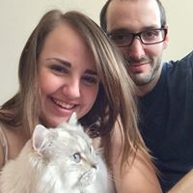
Name: Brooklyn LeClair

What year did you graduate from TRU?

I graduated from TRU in 2014.

What are you doing now?

I’m currently in my first year of law school at the University of Alberta in Edmonton.

How did TRU help you get into grad school, find employment, etc.?

I think what helped me most get into U of A was the excellent teachers I had at TRU. I would say with certainty it was a combination of Dr. Elaine Waddington-Lamont, Dr. Elizabeth Reimer (both of whom wrote my reference letters), Dr. Catherine Ortner and Dr. Reid Webster. They were incredible professors, all who made understanding the materials so easily, and I am so grateful of all the office hours they collectively provided me with.

What did you enjoy about TRU/What did you do while at TRU?

My favourite part of my time at TRU was attending the APS conference with Catherine Ortner and Selina Knorr in San Francisco in May of 2014. It was such an incredible learning opportunity, and I got exposed to so much interesting research I probably never would have found otherwise.

If current students have questions would you be willing to be contacted:

If any current students, especially those who are considering law school, want to contact me (b.leclair@hotmail.com ) I would be more than willing to answer any questions.

