STUDENT SUCCESS COMMITTEE OF SENATE

MEETING AGENDA
  - MEETING INFORMATION
Date: March 27, 2019 Location: TRUSU Boardroom
Time: 14:00 - 15:30

Co-Chairs: Aria Appleton, Archit Gupta, Airini
Note taker: Nicola Forbes
  - DOCUMENTS FOR REVIEW
- Draft Minutes – February 27, 2019
  - AGENDA - Topics
- Call to Order and Acknowledgement of Territory [Aria]
The campuses of Thompson Rivers University are located on the traditional and unceded territory of the Secwepemc Nation within Secwepemcul'ecw. As we share teaching, learning and research within this university, we recognize that this territory has always been a place of teaching, learning and research.
- Adoption of Agenda [Aria]
- Adoption of Minutes (February 27, 2019) [Aria]
- Old Business: [Aria]
  - Mental Health Task Force: Question received: Has the Charter been signed? We look forward to the implementation plan being reported and available for review in Fall 2019.
  - BC Student Outcomes data: http://outcomes.bcstats.gov.bc.ca/Publications/BGSReportsByDiscipline.aspx
- New Business:
  - Strategic Enrolment Management Initiative (Mike Bluhm) [Aria]
  - CBIE (Canadian Bureau of International Education) survey of international students (Kristen Hamilton, IPE) [Aria]
  - Development of Student Success Committee Workplan: [Airini]
      - Purpose of this exercise and relationship with SSSC Terms of Reference (Airini)
      - TRU Strategic Priorities (5) (https://www.tru.ca/__shared/assets/2014-2019_StrategicPriorities_PDF31428.pdf)
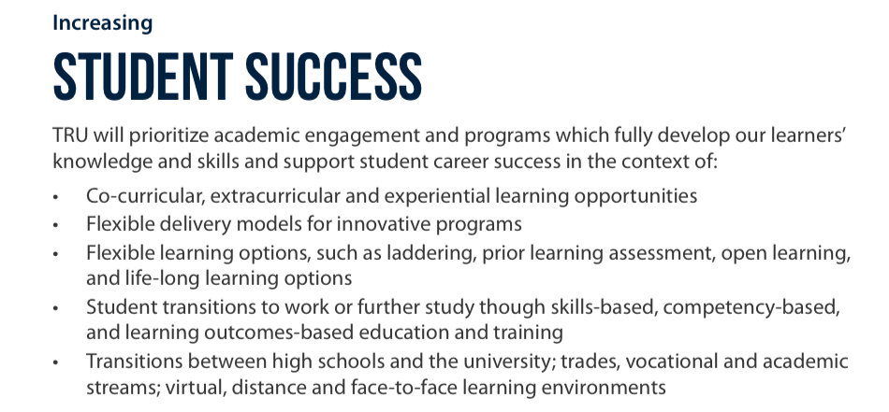
      - Group reporting on ‘4-3-2-1’ exercise (4 students, 3 graduates, 2 co-workers, 1 (yourself): Definitions of ‘student success’) [Airini]
      - TRUSU perspectives on key factors affecting student success [Archit]
      - Current TRU committees and their relationship to student success [Aria]
      - Summary of definitions of ‘student success’ [Airini, with thanks to TRU Library for assistance]
      - EDSW Accreditation – Mission Fulfilment statement – Student Success [Airini]

Source: TRU Accreditation 2017/18 Mission Fulfilment Overview
https://www.tru.ca/__shared/assets/IMFR_Overview_201844120.pdf
      - Drafting of ‘Student Success’ indicators. [Airini]
      - Preparation for working groups to “explore specific aspects of student success (e.g. transition and retention)”, “activities that will foster and promote student success across the University”, and current student success initiatives across TRU (SSSC Terms of Reference 2, 3) [Aria]
      - Proposed questions:
        - Please identify specific aspects of student success (e.g. transition and retention)” that are going well in your Faculty/Division
        - Please identify specific aspects of student success (e.g. transition and retention)” that are challenges in your Faculty/Division
        - Please describe any specific targets your Faculty/Division has set to advance student success (e.g. x% increase in retention in X program by 2020)
        - Please describe current student success initiatives underway in your Faculty/Division
        - Please describe suggestions you have for activities that will foster and promote student success in your Faculty/Division and/or across the University.
- Other Business [Aria]
  - Forthcoming: Report from Matthew Kennedy on SSSC Terms of Reference: “To advise the Accreditation Steering Committee and report on mission fulfilment in relation to the core theme Student Success.”
  - Student Success Committee Co-Chairs meeting with NWCCU Accreditation Visitors (April 1, 2019):
      - Student Success Core Theme work has been done thus far in preparation for accreditations visits. Dean Chris Adam with AVP Enrolment Services Michael Bluhm with others have done this work through a small committee over the past five years.
      - Co-Chairs of the Senate Student Success Committee have been invited to meet with the evaluators on Monday April 1. This meeting is an opportunity to provide historical perspective and also to bring the chairs of the newly (re-)constituted Student Success Committee of Senate directly into the accreditation process.
      - Are there areas of interest the SSSC would like raised?
- Next Meeting: April 24, 2019 – TRUSU Boardroom [Archit]
- Adjournment [Archit]

Student Success Committee of Senate - Terms of Reference

Responsibilities of the Student Success Committee:
- to review and report to Senate on studies and research initiatives associated with Student Success that can assist the university in achieving the goals outlined in the University Strategic Priorities and the Academic Plan.
- To recommend activities that will foster and promote student success across the University.
- To develop working groups to explore specific aspects of student success (e.g. transition and retention).
- To advise Senate on policies related to student support and services.
- To advise Faculties, Schools and the Senate on opportunities to foster and enhance linkages between student support activities, academic programs and learning outcomes.
- To advise the Accreditation Steering Committee and report on mission fulfillment in relation to the core theme Student Success.

Composition
- Chair: A Committee member elected by the Committee
- Associate Vice-President, Strategic Enrolment and University Registrar (or
- designate)
- Associate Vice-President, Open Learning (or designate)
- Dean of Students
- Director, Centre for Excellence in Learning and Teaching (CELT)
- Director, Integrated Planning and Effectiveness (or designate)
- Executive Director, Aboriginal Education (or designate)
- Associate Vice-President, TRU World (or designate)
- One Dean
- University Librarian (or designate)
- Two CELT representatives, appointed by the Director
- One representative appointed by the Alumni Association
- Four (4) Faculty and/or Open Learning Faculty Members appointed by Senate
- Up to seven (7) Students nominated by TRUSU and appointed by the Senate
- Steering Committee
  - Secretarial Support: Office of Dean of Students

Ex Officio Non-Voting Members:
- Accreditation Liaison Officer

MEMO
To: Senate Student Success Committee
From: Aria Appleton, Airini, Samira Keivanpour
Re: ‘Student Success’ as a work area in TRU Committees
Date: 26 March 2019
This memo provides a short analysis of the presence of ‘student success’ in the terms of reference for Senate committees at Thompson Rivers University. Of the 12 Senate Committees, two include explicit reference to student success/ the success of students in their terms of reference: First Nations and Aboriginal Affairs Committee, and the Student Success Committee.

SENATE COMMITTEES AND ‘STUDENT SUCCESS’
The powers of the Board are set out in section 9 of the TRU Act. The following table shows where and whether ‘student success’ features (explicitly or implicitly) in the Terms of Reference for each Senate Committee.

Senate Standing Committee | Student Success in Terms of Reference
Awards and Honours Committee | Advise Senate on policies, procedures, priorities and criteria for student awards and honours.  Evaluate student candidates for medals and select awards and make recommendations to Senate.
Academic Planning & Priorities Committee of Senate (APPC) | Advise Senate on the mission statement and the educational goals, objectives, strategies and priorities of the University
Budget Committee | Advise Senate and its committees on the budgetary implications of matters within the jurisdiction of Senate and its Committees, including proposals for new educational, research or other programs or initiatives, as required by Senate and its committees
Educational Programs Committee of Senate (EPC) | Advise Senate on all matters related to the educational programs of the University  Advise Senate on policies concerning student withdrawal from courses, programs or the University  Advise Senate on policies, practices and criteria for the admission, evaluation and promotion of students except for those matters within the jurisdiction of the Planning Council for Open Learning  Advise Senate on the criteria for awarding certificates, diplomas and degrees
Environmental Sustainability Advisory Committee (ESAC)
First Nations and Aboriginal Affairs Committee (FNAAC) | Advise Senate on measures to promote, support and celebrate the success of students of aboriginal ancestry
Graduate Studies Committee | Advise Senate on Student Academic Policies including but not limited to policies, practices and criteria for the admission evaluation and promotion of student [sic] except for those matters within the jurisdiction of the Planning Council for Open Learning.  Advise Senate on the criteria for awarding graduate certificates, diplomas and degrees.  Promote best practices for graduate student engagement including but not limited to graduate teaching and research assistants, internal scholarships, travel bursaries, and other internal awards, including awards for outstanding graduate student supervision.
International Affairs Committee | Advise Senate on measures to achieve the goals set out in the University’s Strategic Plan and Academic Plan with regard to international opportunities with a focus on internationalization and increasing the number of international opportunities for TRU students and faculty;
Research Committee | Advise Senate on policies and programs that promote, support and celebrate high quality research and scholarly work and its dissemination
Steering Committee
Student Success Committee | To review and report to Senate on studies and research initiatives associated with Student Success that can assist the university in achieving the goals outlined in the University Strategic Priorities and the Academic Plan  To recommend activities that will foster and promote student success across the University  To develop working groups to explore specific aspects of student success (e.g. transition and retention)  To advise Senate on policies related to student support and services  To advise Faculties, Schools and the Senate on opportunities to foster and enhance linkages between student support activities, academic programs and learning outcomes  To advise the Accreditation Steering Committee and report on mission fulfillment in relation to the core theme Student Success.
Teaching and Learning Committee | Advise Senate on policies, programs and practices to promote, support and celebrate high quality and innovative teaching and learning environments.  Advise Senate on policies and practices for the systematic measurement of the quality of teaching and learning, and on the promotion of research on teaching and learning.

