ACM Training

Logging In

Go to http://acm.tru.ca and use your supplied credentials, typically first initial last name, like so:
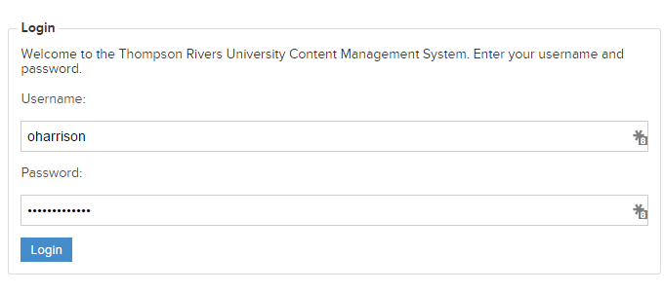
Upon successful login, you’ll be taken to the Login page, where you’ll see a list of all the TRU sites.

Top Menu Bar

When you’re logged in, you’ll always see the below bar at the top of your page. It provides quick links to some useful ACM tools, such as My Page, My Site, Site Menu, and page-specific Help.
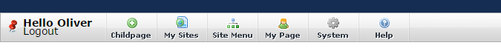

My Page

My Page is where you go to change your password, change your visual editor style and upload a photo.
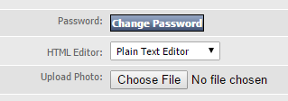

Navigation
When using the ACM, you will notice that on the landing page, you will not see every site. To Navigate to your site, you will access it via your department or faculty section. For instance, to get to the Marketing & Communications Web Services section, I would follow this path:
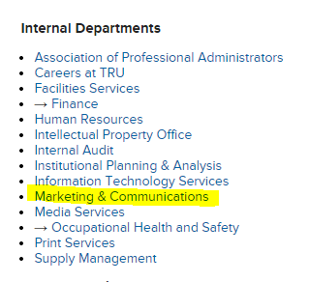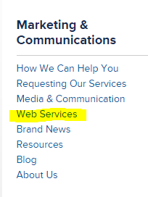

Quick Edit vs Full Edit
On every page that you have the rights to edit, you will see 2 main buttons above the content area.
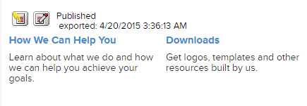
The Yellow button indicates ‘Quick Edit’ while the Red button indicates ‘Full Edit’. Quick edit is predominantly for text or other minor in-page edits, while the Full Edit option allows you to create New Subpages and more.

Page Summary Form & Best Practices
The first four fields on any page in the ACM are title Page Summary. Best practices for filling them out are as follows:
- Title - This is the only required field. This field will be shown as the in-page title if your template supports it. For example, this page's Title is 'Home - Development Area'.
- Menu Title - This will become the title of the menu item for this page. If you do not enter anything here, your page's menu title will be taken from the Title field.
- URL Title - This will become the page's name in the address bar. It is best to use hyphens if necessary, as opposed to using underscores. It will be generated automatically if you don't fill this out - it is best to manually enter a title that is short and descriptive. For example, 'Campus Switchboard and Telephone Directory' could become 'switchboard-directory'.
- HTML Title - This is the field that will be shown as the title in your browser's tab when you load the page. It is best to be descriptive here. We use the format Page Title, Department - Thompson Rivers University. For example: Campus Switchboard and Telephone Directory, IT Services - Thompson Rivers University.

Edit Page Tabs
- Content: On this tab, you will see the content of the page you are currently editing. It will look similar to the page on the external site.
- Child Pages: On this tab, you can view the Child Pages of the page you are on as well as create a new Child Page of this page.
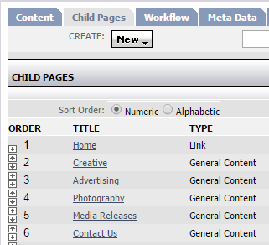
- Workflow and Meta Data can be ignored.
- Pagelets is where you modify the pagelets on a page – this is covered in Advanced training.
- Design: This tab is not visible to most users.
- Page History: This is where you will revert your page to a previously published version.

Child Pages
Child pages allow you to nest multiple pages in a multi-tiered menu, like the following. Use the Page Summary Form Best Practices as outlined above to create a Child Page.
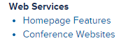

The Visual Editor
The Visual Editor has a similar look to an old version of Microsoft Word or WordPress. It allows you to edit your page content visually, seeing the changes you make on the fly.
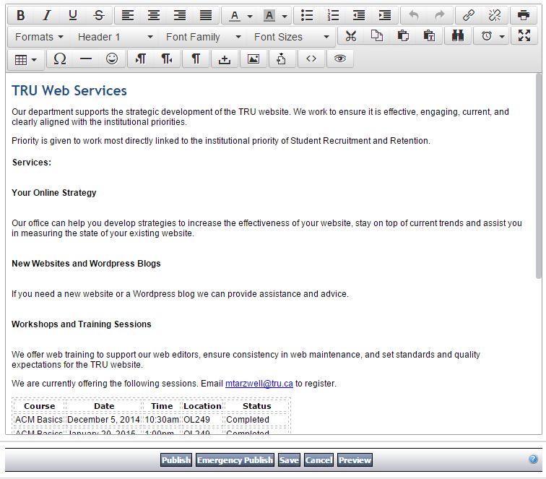

Publish, Emergency Publish, Save, Preview
When you are ready to save your changes, you have some options.
- Publish: This instructs the server to publish the page. It cannot be undone – you cannot ‘unpublish’ a page, though you can keep it from showing in the menu until you’re ready for it to be live. Publishing a page will make it live to the public at midnight on the day it is published (ie: tomorrow).
- Emergency Publish: This instructs the server to publish the page immediately. In about 3 seconds, the page will be live to the public unless the page is a top-level page such as the Faculty of Arts homepage. In these cases, emergency publishing a page will take approximately 15 minutes for the changes to be live.
- Save: Saving a page will simply save your changes but not publish them.
- Preview: This will open a new browser tab, showing you what the page will look like in your site’s template. You may need to modify your browser settings so that it does not block the popup:

Digital Assets
Digital Assets are files that you upload to the server. They can be a variety of file types DOC, DOCX, XLS, XLSX, PPT, PPTX, PDF, GIF, JPG, PNG. They are shown in a list and often have icons indicating the file type:
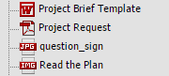
The button to insert or upload a digital asset looks like this: 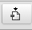
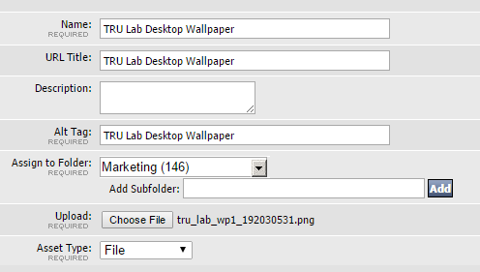
When uploading a new file, click on the Add tab in the popup window:
- Name: This is the Name of the file and will appear in the ACM Digital Assets list
- URL Title: This is the name of the linked file when inserted into a page (for DOC, XLS, PDF)
- Alt Tag: This is the Alt Tag for images, used to make images accessible for non-sighted users.
- Assign to Folder: This is where the file will be uploaded to.
- Asset Type: This is always File.

Links
When creating a link, select your text to be linked, then click on the chain icon.
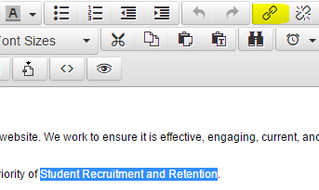
This will open a popup window, allowing you to paste or type in the link to an External site, or choose the internal page you want to link to.
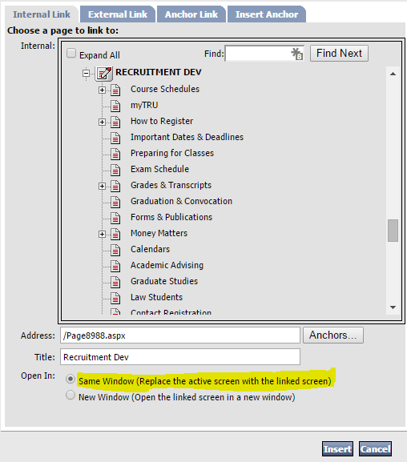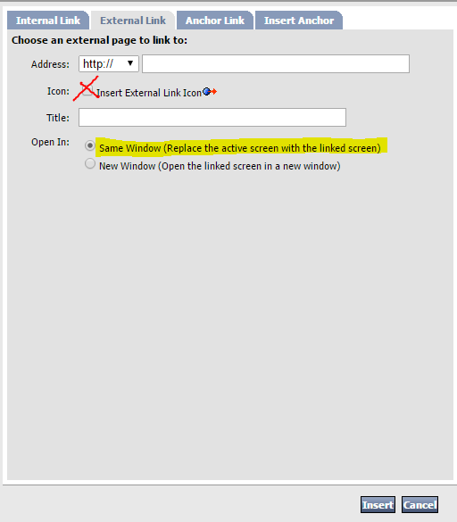
Please make sure that Open In: Same Window is always checked, unless the site is a page that MUST be opened as an external link. Do NOT use the Insert External Link Icon.

Revisions & Page History
In order to revert your page to an older version, click on the Page History tab and click on the version you’d like to revert to:
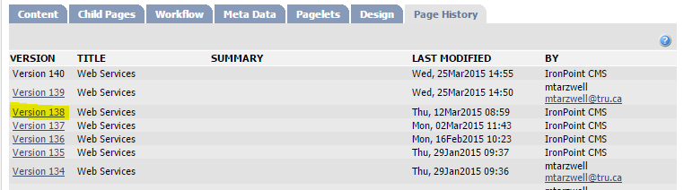
You will then be presented with a view of the Page Version you’ve clicked on, giving you the option to Restore that version or Cancel.

Help
In-page help is always available, giving you quick answers to common questions. On any page, click on the top bar’s Help button, or the ? symbol on any page element:
